Mid-Term 2 Report
Team 21
Optimization of the Turning Mechanism in a Maritime Target System

Members:
Timothy Lootens - twl12
Tomas Fajardo - t13b
Charles Kelly - ctk12b
Nicolas Salazar - ns14k
Jonathan Rhoads - jsr12j
Scottie Milton - scottie1.milton
Faculty Advisor/s
Camilo Ordonez
Jerris Hooker
Sponsor/s
Jason Knowles
Instructor/s
Nikhil Gupta/ Chiang Shih
December 5, 2016
Table of Contents
Table of Figures iv
Table of Tables vi
ABSTRACT vii
ACKNOWLEDGMENTS viii
1. Introduction 1
2. Project Definition……………………………………………………………………………...2
2.1 Need Statement 3
2.2 Background Research: Competitors 3
2.2.1 SP Targets………………………………………………………………………….......3
2.2.2 Elite Target Systems TACII……………………………………………………………4
2.2.3 MotoShop………………………………………………………………………………5
2.3 Background Research: Electrical Components 5
2.4 Goal Statement and Objectives 8
2.5 Constraints………………………………………………………………………….............9
3. Design Methodology…………………………………………………………………………...9
3.1 House of Quality 9
3.2 Morphological Chart 12
3.2.1 Preliminary Design 1 13
3.2.2 Preliminary Design 2 15
3.2.3 Preliminary Design 3 16
4. Design and Analysis……... …………………………………………………………………...?
4.1 Selected Preliminary Design .?
4.4.1 Mechanical Design .?
4.4.2 Electronic Components .?
4.4.3 Software Development .?
5. Future Work ?
5.1 Rough Manufacturing ?
5.2 Electronics and Software Alpha Testing ?
5.3 Design Refinement ?
5.4 Final Design Testing ?
6. Results…………..………………………………………………………………………..…...18
7. Conclusion……...…………………………………………………………………………….19
References 21
Appendix A 22
Appendix B 24
Appendix C 26
Biography 31

Table of Figures
Figure 1: The prototype of the Odyssey model provided by the sponsor 2
Figure 2: The SPTargets Running Man model.^{[1]} 3
Figure 3: Elite Training System Tac II model.^{[2]} 4
Figure 4: MotoShot Turning Target System Design.^{[3]} 5
Figure 5: Electrical Housing and Components. 6
Figure 6: Arduino UNO (left) and Arduino Micro (right).^{[4]} 7
Figure 7: ESP8266 – 12 Wi-Fi Serial Module.^{[5]} 7
Figure 8: Speedstudio 433MHz RF Long Distance Transmitter/ Receiver Pair.^{[6]} 8
Figure 9: ProE Model of Preliminary Design 3. 14
Figure 10: ProE Model of Preliminary Design 2. 15
Figure 11: ProE Model of Preliminary Design 3. 17
Figure 12: Electronic System Schematic.
Figure 13: Software platform options.
Figure 14: Preliminary app interface.
Figure 15: Dimensioned Drawing of Design 1 Assembly. 22
Figure 16: Detailed Drawing of Design 1 Component. 22
Figure 17: Detailed Drawing of Design1 Component. 23
Figure 18: Detailed Drawing of Design 1 Component. 23
Figure 19: Dimensioned Drawing of Design 2 Assembly 24
Figure 20: Drawing of Arm for Design 2. 24
Figure 21: Drawing of design 2 target mounts. 25
Figure 22: Integrated Sleeve and Support. 25
Figure 23 Detailed Drawing of Design 3 Assembly. 26
Figure 24: Drawing of Design 3 Component. 26
Figure 25: Detailed Drawing of Design 3 Component. 27
Figure 26: Detailed Drawing of Design 3 Component. 27
Figure 27: Detailed Drawing of Design 3 Component. 28
Figure 28: Detailed Drawing of Design 3 Component. 28
Figure 29: Detailed Drawing of Design 3 Component. 29
Figure 30: Detailed Drawing of Design 3 Component. 29
Figure 31: Detailed Drawing of Design 3 Component. 30
Figure 32: Detailed Drawing of Design 3 Component. 30

Table of Tables
Table 1: House of Quality developed by Group 21.^{[7]} 10
Table 2: Morphological Chart Developed to Produce Preliminary Designs.^{[7]} 13
Table 3: Morphological Chart for Design 1.^{[7]} 14
Table 4: Morphological Chart for Design 2.^{[7]} 15
Table 5: Morphological Chart for Design 3.^{[7]} 16
Table 6: Decision matrix. +1 (better), 0 (same), -1 (worse). Secondary check through CI’s.^{[7]} 18

ABSTRACT
Sea target training systems provides maritime target systems for all branches of law enforcement, homeland security and the military. Jason Knowles, the CEO of Sea Target Training Systems, LLC has requested our services to possibly redesign, improve and/or optimize the turning system on one of his upcoming base maritime target models. His specific needs for this remotely controlled target system are a user-friendly interface, Wi-Fi and mobile app controlled program and durable hardware for in service conditions. His goal is to introduce a state of the art training device that will revolutionize the maritime training curriculum with a highly realistic simulation feature. The team has generated three preliminary concept designs each meeting the customer’s needs and requests. Through the use of several design methods a final prototype design has been selected for initial design analysis and testing.

ACKNOWLEDGMENTS
Group 21 would like to thank Jason Knowles, CEO of Sea Target Training Systems for his sponsorship of our project. His help and availability have been encouraging. Thank you for providing a prototype to Group 21 early within the semester.
Group 21 would like to thank Dr. Camilo Ordonez for advising our project and for giving valuable insight to our project. Dr. Ordonez has been a strong resource for Group 21 in preparation for the mid-term presentation as well as asking important technical questions. In addition, we would like to give a special thanks to Dr. Jerris Hooker from the Electrical and Computer Engineering department for providing wonderful support in the software and electronics portion of the project.
Group 21 would like to thank the Mechanical Engineering Department of the College of Engineering for providing opportunities such as this project and for providing helpful course material to guide Group 21 in our progress.

Introduction
Firearm training has always been an important focus on police and military training processes. This creates a large market for advancements in training technologies. Group 21 has been brought on board a business venture that will aim to further these advancements. Group 21 has been tasked by their sponsor to redesign and improve this unique target system while accounting for the important constraints and objectives developed through their partnership and discussions with the sponsor. Jason Knowles, CEO of Hard Target Security Group and Sea Target Systems, LLC, is a special agent for the Florida Department of Law Enforcement. He’s done service with the Tallahassee Police Department and while with the USMC Scout Snipers, he was in charge of special ops and marksmanship training. His main theme in marksmanship training was physiological applications, meaning aiming while under stressed conditions. He realized that this was an important concept when training since in times of need, one has to be able to shoot accurately by instinct and automatic body function. While considering this concept, he realized an opportunity for optimal heuristic training: maritime training. By being able to train accuracy while standing in a vessel with factors such as wind, unstable grounding and moving targets, maritime training can be the solution to effective law enforcement and military weapons training. To this date, there is no maritime training program that is available to both law enforcement and the military. With this in mind, he started Sea Target Systems, LLC and began designing the first sea target system.
This report will walk through each step of the engineering design process that Group 21 has accomplished up until now as well as mention plans for accomplishing future goals. First, Group 21 addressed the project definition, where the need is defined and background research is done. Through this research, Group 21 learned that the idea of a maritime turning target system is a very unique and original idea. Because of this, our sponsor has made an important point for all group members and involved parties to sign a non-disclosure agreement to maintain privacy of this product information. The biggest concern of the sponsor was the team webpage. All documentation for this project that would usually be promptly posted to the web page upon completion will first be confirmed through the sponsor. The sponsor holds the right to stop any product-based information from being posted to the web page as he sees needed.
At this time, Group 21 has created three preliminary designs and has chosen the best design based on the research done in the project definition. This preliminary design is subject to re-designs and is a working model of what Group 21 wants to accomplish with this project.
- Project Definition
The project that Group 21 has been tasked with is to take an existing maritime turning target system prototype, developed by the sponsor, and make the changes that are necessary to turn this prototype into a marketable product. This target system is equipped with a turning mechanism that controls the motion of the targets. Figure 1 shows the prototype that the sponsor has provided to Group 21.

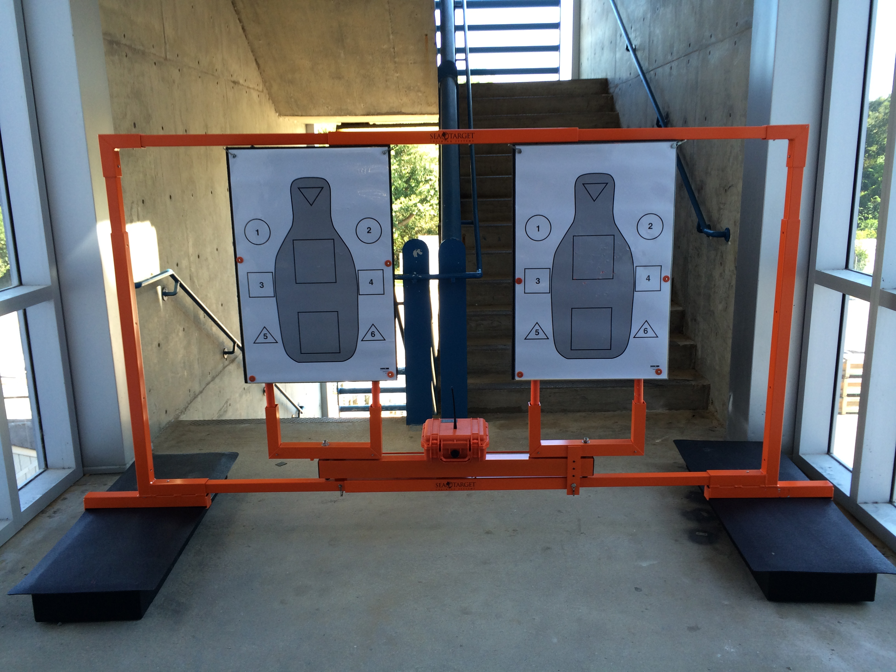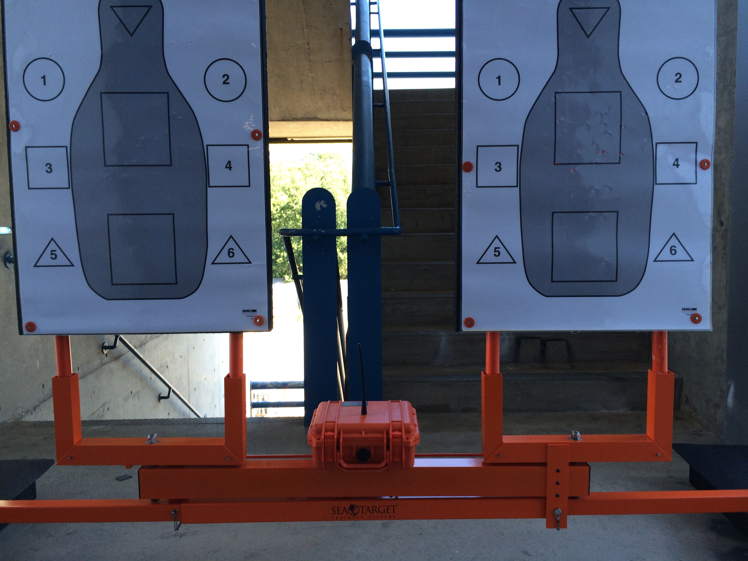
Figure 1: The prototype of the Odyssey model provided by the sponsor
The left picture shows the full prototype, which is in Group 21s’ possession. The system is comprised of four main subsystems. The first being the two black floatation devices attached to the bottom of the system. Second is the orange aluminum flame, which provide structural integrity to the system as well as a hanging option for the targets. Third is the orange aluminum turning target mechanism, which is attached to the bottom of the flame with two small pins. Finally final main component is the actual targets. The right picture is focused in on the scope of the project, which is the turning mechanism of the target system. Currently, the design of the turning target is mechanically flawed and electronically outdated. Group 21 will be focused on the improvement of this mechanism. Improvements to any other subsystem are possible with approval from the sponsor but are currently outside of the project scope.
As stated in the introduction, there is no product on the market similar to this type of target system and there is a lack in the firearm training industry for realistic training scenarios. This project will help the heuristic training ability of many police and military personnel through realistic training environments.

2.1 Need Statement
Group 21 has developed the following needs statement based on the knowledge that there are advancements to be made in the maritime target training industry:
“Maritime sea training targets lack turning features that provide realistic training scenarios.”

2.2 Background Research: Competitors
Because there is no product on the market that matches the sea target that Group 21 will be working on, three land bound target systems, which have similar turning features, were researched and the findings will be discussed here.
2.2.1 SP Targets
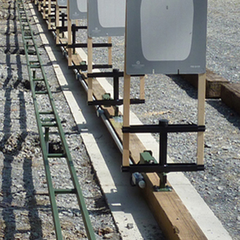
Our first competitor that was research was SP Targets and their Running Man target model. This product uses many turning aligned in a row to give the shooter a challenge to react to a shoot/ no shoot situation. Figure 2 shows a row of installed SPTarget Running man model.

Figure 2: The SPTargets Running Man model.^{[1]}
This model uses a frame of mostly steel, which provides a cheap and strong solution for the frame material. The downside to steel is that it makes the product heavy compared to the model that Group 21 is looking to design. The targets have independent motion, which again lead to the reaction training. One downside to this product is that it is permanently installed or fixed and is not portable. Group 21s’ target system is easy to assemble/ disassemble and transport making it usable in any possible environment available. A “control system receiver” controls the motion of the targets. This is all that is said about the electrical connection on the SPTarget website.
2.2.2 Elite Target Systems
The next competitor who produces a turning target system is Elite Target Systems with their TAC II model. Figure 3 shows the turning target system.
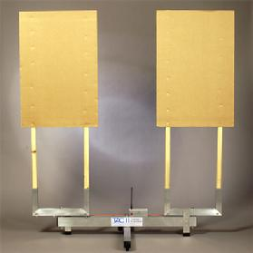
Figure 3: Elite Training System Tac II model.^{[2]}
Again this target is meant for land use only. The target system that Group 21 is improving is based off of this design and is very similar. Two main differences are that Group 21 will produce a model that is controlled through a Wi-Fi connection and the whole design will be waterproof. Another difference is that TAC II, like our current prototype, employs the use of one motor making the target move dependently. Group 21 is aiming to have independent target motion.

2.2.3 MotoShot
The final competitor that was be detailed in this report is the MotoShot turning target system. Figure 4 shows the turning target model.
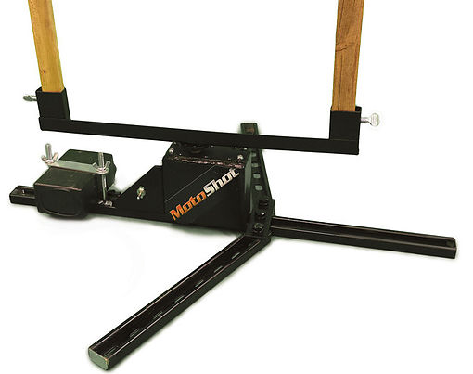
Figure 4: MotoShot Turning Target System Design.^{[3]}
This design uses only one target and meant to be bolted to the floor. This allows the target to have a very simple and minimalist design. A downside of this design is that practicing with multiple targets for a realistic training scenario requires the purchase of multiple target systems, which can get expensive for the customer. Like the Odyssey (current prototype), this design uses radio frequencies and a small remote to control the motion of the targets. Motoshot uses steel for their frame, which provides better bullet resistance than aluminum.

2.3 Background Research: Electrical Components
The current design of the Odyssey (prototype) employs the use a number of different electrical components. First, a small remote is used to send commands to a control box that serves as the controller for the motor, which powers the turning motion of the targets. This is all run off of a 12 Volt battery. The battery and the control box are housed inside of a watertight Pelican Case made of Polypropylene Copolymer. Figure 5 shows the electrical housing and its’ components.
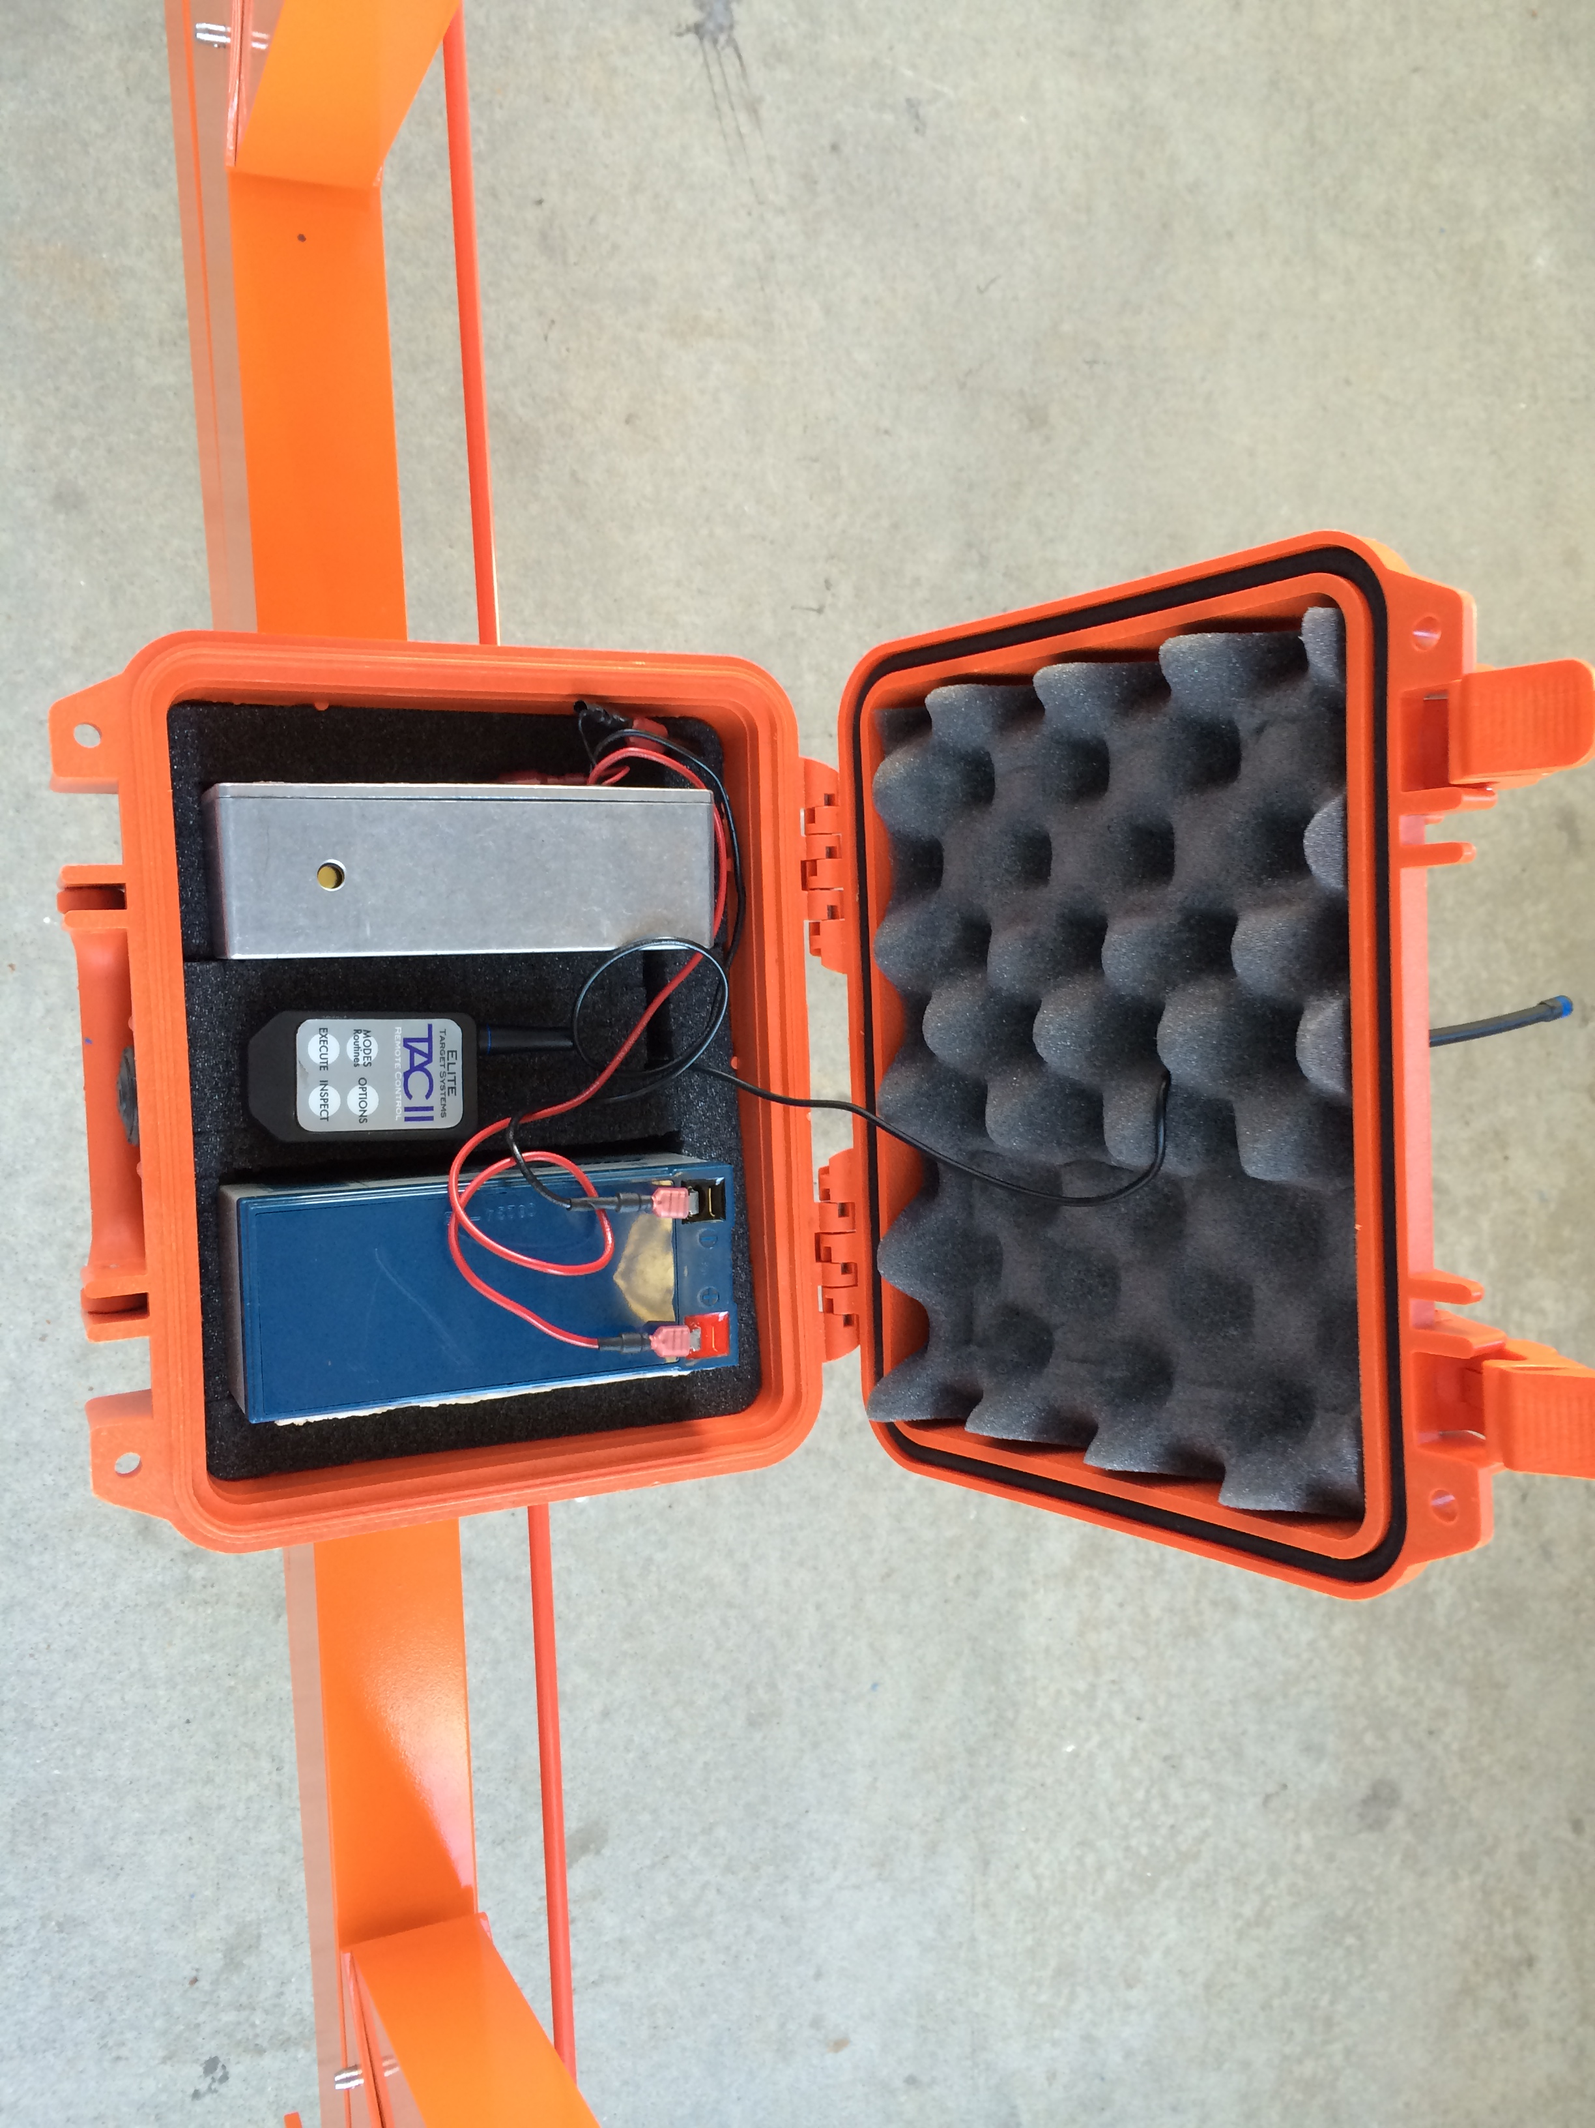
Figure 5: Electrical Housing and Components.
To move towards creating a Wi-Fi connection between the user’s smartphone and the turning target system, Group 21 is looking to change the current configuration of the prototype to be more sleek and practical in live-fire training scenario. Although the Pelican case provides adequate water resistance, the plastic material lacks the ability to protect the internal electrical components from damage if it were to get hit with a stray bullet. The case itself is also located too close to the targets and leads to bullet resistance vulnerability due to this proximity. Group 21 will be developing changes to increase the bullet resistance while maintaining the water resistance that currently exists in the system.
As far as the internal components are concerned, Group 21 has done research into what types of products could be utilized in creating a functioning Wi-Fi connection between the user’s smartphone and the target systems’ turning mechanism. We will now discuss how this connection will be made the potential parts that could be used to establish the connection.
First, it is important to understand that we are considering maintaining the use of radio frequencies for communication. This allows for much higher connectivity and range than compared to using a Wi-Fi connection in a maritime environment. While the shooter is training on a boat, there needs to be a Wi-Fi enabled microcontroller also located in the boat. Figure 6 shows two options of microcontrollers that would adequately perform this function.
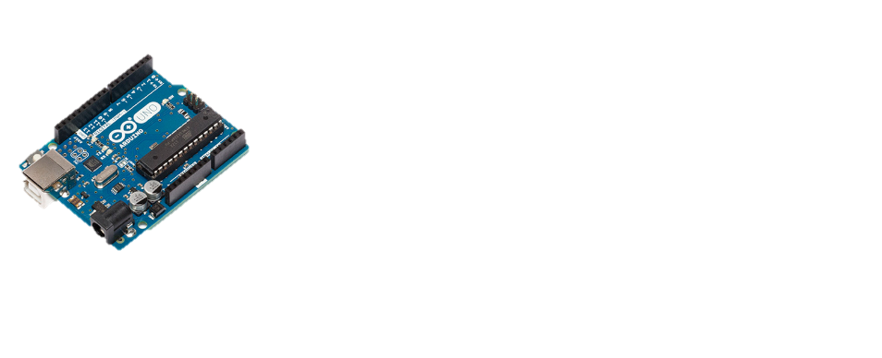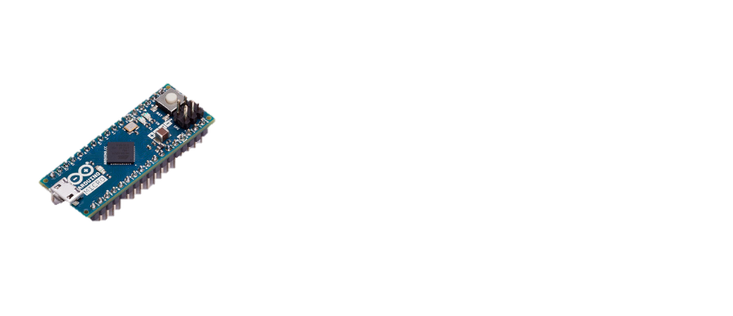
Figure 6: Arduino UNO (left) and Arduino Micro (right).^{[4]}
The Arduino UNO (left) costs $30 and has 32KB of memory. It also supports a USB connection to allow a wired connection between smartphone device and microcontroller if needed. The Arduino Micro (right) costs $25 and is smaller than the UNO and consumes less power. It also has slight more SRAM than the UNO as well as more input/output pins. This chosen microcontroller will use a Wi-Fi module to establish connection to the user’s smartphone device. Figure 7 shows the Wi-Fi serial module that could be used by the microcontroller.
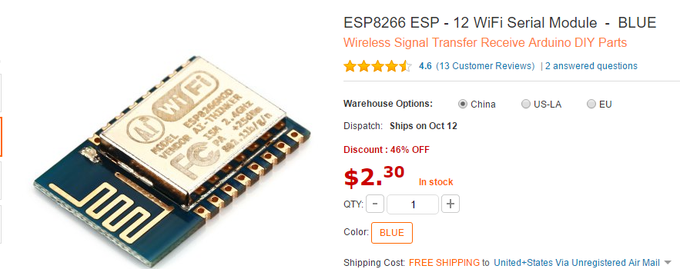
Figure 7: ESP8266 – 12 Wi-Fi Serial Module.^{[5]}
This will establish a Wi-Fi connection so that the user only needs to operate their smartphone device. The microcontroller will then send radio waves through a radio frequency transmitter. A radio frequency receiver that is connected to another microcontroller on the target system will receive this signal. Figure 8 shows a potential option for the long distance radio frequency transmitter and receiver.
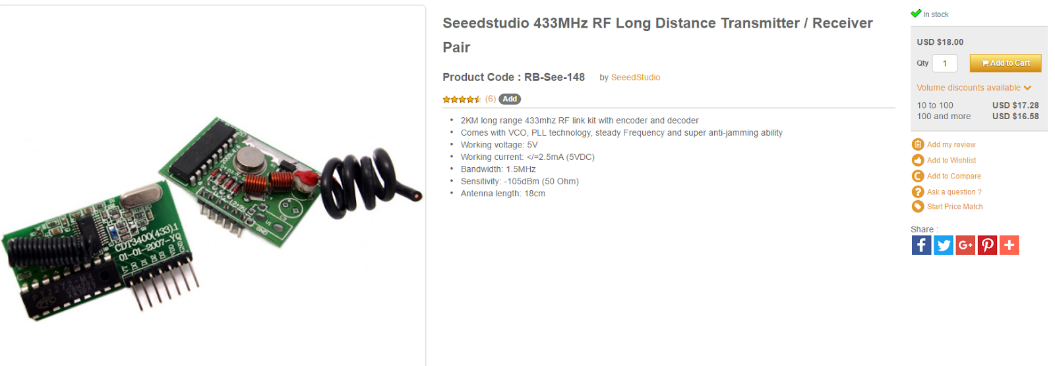
Figure 8: Speedstudio 433MHz RF Long Distance Transmitter/ Receiver Pair.^{[6]}
The radio frequency receiver will communicate with the microcontroller to control the motor driver and the motor. From there the motor will control the motion of the targets.

2.4 Goal Statement and Objectives
In response to our need statement with the knowledge gained from background research, a goal statement was developed by Group 21 to address the Odyssey (current prototype). The goal statement is as follows:
“Improve and optimize the electrical and mechanical design of the maritime sea target system’s turning mechanism, while maintaining the lightweight, affordable and practical functions of the existing design.”
Along with the goal statement, important project objectives were developed through clear requirement given by the sponsor as well as objectives developed by Group 21 while they have proceeded through the engineering design process. The objectives are as follows.
- Design an efficient turning mechanism controlled through a Wi-Fi connection.
- Develop an application that is compatible with both iOS and Android devices in order to control the rotation of the target.
- Develop programs in the application to control the manner in which the target rotates, pauses, and returns.
- This needs to be a marketable product so the design must maintain affordability.
- Maintain quality of materials and housing of electronics.
- Maintain practical frame design and ease of assembly.
- Improve the stability of the connection between the turning mechanism and the frame of the target.
2.5 Constraints
All engineering projects experience some sort of limitations on their designs or constraints. Some may be the most trivial such as time or money. But, all types of projects and situations bring about a new set of constraints that may not be as apparent. In the case of Group 21’s remotely controlled target system project, some constraints are inherent by nature and some stem from the sponsor’s or customer’s needs and requirements. Below is a list of the constraints for this particular design project.
- Controller must have a range of at least 100 yards.
- Power the servomotor for the turning mechanism with a 12V battery.
- The mechanical design needs to be waterproof to protect the electronic components.
- All components need to be corrosion resistant as it will be in constant contact with water.
- The mechanical design needs to improve on the bullet resistance of the prototype.
- The ideal weight of the target is not to exceed 30 pounds.
- The final design must operate within the dimensions of the existing frame of the Odyssey prototype (4ft x 4ft)
- Design Methodology

3.1 House of Quality
The house of quality is an important feature of the engineering design process that allows for the analysis of important customer requirements and how they relate to the engineering characteristics and competitor analysis of the design process. Group 21 created a house of quality in order to determine which aspects of the design will be most important and will have the greatest impact on customer satisfaction. Table 1 shows the house of quality.
Table 1: House of Quality developed by Group 21.^{[7]}
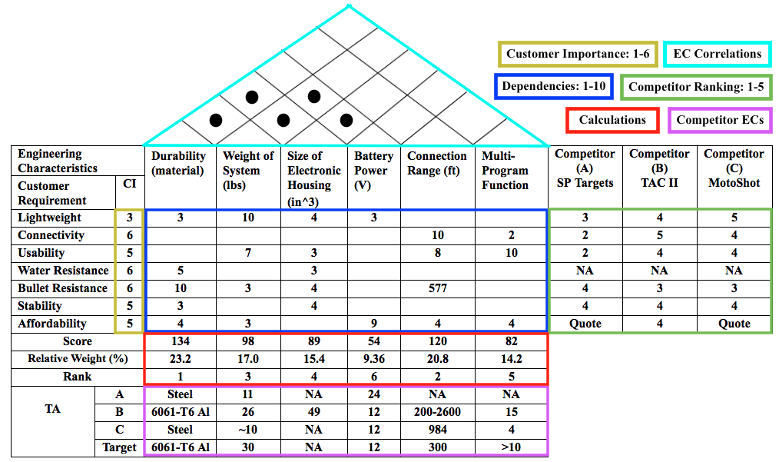
First, Group 21 brainstormed and formulated a list of requirements that would be most critical in terms of customer satisfaction. Some of these requirements stem from Jason Knowles (sponsor) and proof of concept feedback he had received. These customer requirements (CR) were then ranked on a scale of customer importance from 1-6. The first requirement was that the system is lightweight and got an importance of three because our sponsor is not too worried about the weight changing enough to affect the portability of the design. Connectivity (6) is a key requirement given by our sponsor, as the whole point of the project is to control the target through a Wi-Fi connection. Usability (5) is another important aspect of the project and does not only include the user-friendliness of the mobile application but also the ease of assembly/ disassembly of the system. Water resistance and bullet resistance are both key durability aspects of the project whose presence in the system are key to the success of the project overall. Stability (5) is a requirement that Group 21 developed through reverse engineering the design and is a needed improvement to make this product marketable. The affordability (5) of the product is an important factor when our sponsor gets to the point of manufacturing and selling this product.
Following the creation of the customer requirements, Group 21 established a list of engineering characteristics that are the most vital aspects of the design. These characteristics include the durability of the system, the weight of the system, the size of the electronic housing, the battery power, the connection range, and the multi-program functionality of the mobile application.
Then the team created a correlation matrix determining how much or how little the engineering characteristic in question impacted a customer requirement. These correlations can be seen in the blue section of Table 1. If any of the engineering characteristics were correlated to a customer requirement, a value from 1-10 was assigned based on how strong that correlation was. Our strongest correlations came from weight of the system and lightweight, the durability of the material and the bullet resistance of the system, the connection range and the connectivity, as well as the multi-program functionality with usability of the mobile application.
In the red calculation section of the HOQ, the correlations number between the EC’s and the CR’s was multiplied by the customer importance value and added up as the score. From these values, the engineering characteristics could be assigned relative weights and ranks of importance. It can be seen at the bottom of this section that the engineering characteristics with units of measurements are ranked from most important the least in the following order.
- Durability of the System (material)
- Connection Range (feet)
- Weight of the System (pounds)
- Size of the Electronic housing (cubic inches)
- Multi-Program Functionality (number of functioning programs)
- Battery Power (Volts)
The top section of the HOQ is the engineering characteristics correlations. In this section, any dependencies between engineering characteristics are recognized with the use of a black circle. The first dependency was a weak dependency of increasing the weight of the system’s material also increases its durability. Another dependency was that as the size of the electronic housing decreases, the less likely it is to hit by stray bullet; increasing the durability of the system. Decreasing the size of the electronic housing would also likely decrease the weight of the system. There were also weaker dependencies between the battery power and the size of the electronic housing as well as the weight of the system.
Furthermore, a comparison of competitors’ products and their impact on the customer requirements formulated by Group 21 is shown to the right of the correlation matrix of the house of quality diagram. It can be seen in this green section that our stronger competitors are TAC II and MotoShot having strengths in the lightweight, connectivity, and stability aspects of their designs. It is important to note that none of these competitors are maritime target systems so water resistance was not a fair comparison and unnecessary. Also, neither SPTargets nor MotoShot provided prices for their products.
Finally, the bottom purple section of the HOQ is the competitor characteristics. This simply tabulates actual data for the engineering characteristics that were provided by the competitor’s websites [1-3]. These values are compared to target values of the Group 21’s goal model. All four models use either steel or aluminum as the frame material. The weight of the systems ranges from 10 to 30 pounds. Only Elite Target Systems provided a size of the electronic housing unit (49 cubic inches). All models use 12 Volt batteries except for the SPTarget model (24V). There are large differences in the connection range of the electronic components. Finally, the number of available program functions range from 4 to 15 with SPTarget’s number not available.

3.2 Morphological Chart
After establishing a functional house of quality, Group 21 took the next step in the engineering design process and began to develop a morphological chart, which leads to preliminary designs. From information gained from the house of quality, Group 21 developed important requirements for the morphological chart to include. These requirements were motion, stability, lightweight, and durability and electronics housing. These are all important issues in the design of the target system. Table 2 shows the morphological chart with requirements that were based off of the customer requirements found in the house of quality.

Table 2: Morphological Chart Developed to Produce Preliminary Designs.^{[7]}
Requirements | Functional Parameters | Concepts to Satisfy the Function
Motion | Type of Motor | Servomotor |  | Stepper Motor
 | Power | Single Motor |  | Dual Motor
 | Targets | Dependent |  | Independent
Stability | Support/Sleeve Connection | Integrated | Bracketed |  | Welded
Lightweight | Material | Aluminum 6061 | Steel |  | Carbon Fiber
Durability and Electronics Protection | Bullet Resistance | Metal Housing | Inside Support Beam |  | Underwater Housing
 | Water Resistance |  |  |  | Pelican Case

Breaking down these requirements into more specific categories, functional parameters were defined to meet needs of the requirements. Then, specific solutions were collected that could potentially satisfy the requirement. For the requirement of motion, the parameters were the type of motor, power, and target motion. The solutions for type of motor were servomotors or stepper motors. For power it was either using one or two motors. For target motion there are the options of dependent or independent motion. To solve the requirement of stability, connecting the support and sleeve components through integration, brackets, or welding was proposed. To make the design lightweight, Aluminum 6061, steel, and Carbon fiber were all proposed. Finally, for the requirement of durability and electronics protection, bullet resistance and water resistance were the functional parameters. For both parameters, solutions for the electronics housing were metal housing and locating them inside the support beam. Also for bullet resistance, underwater housing was proposed and for water resistance, a pelican was proposed. Upon iterative use of this morphological chart, Group 21 developed ideas for three preliminary designs.

3.2.1 Preliminary Design 1
From the first iteration of the morphological chart, Group 21 established a design that solves the important requirements described in Table 3.
Table 3: Morphological Chart for Design 1.^{[7]}
Requirements | Functional Parameters | Concepts to Satisfy the Function
Motion | Type of Motor | Servomotor |  | Stepper Motor
 | Power | Single Motor |  | Dual Motor
 | Targets | Dependent |  | Independent
Stability | Support/Sleeve Connection | Integrated | Bracketed |  | Welded
Lightweight | Material | Aluminum 6061 | Steel |  | Carbon Fiber
Durability and Electronics Protection | Bullet Resistance | Metal Housing | Inside Support Beam |  | Underwater Housing
 | Water Resistance |  |  |  | Pelican Case

It was decided that two servomotors would provide a exciting ability for independent motion of the targets. For stability, welding the support and the sleeve was chosen. Aluminum 6061 was chosen as the optimal material for its’ balance of weight, cost, and strength. A metal housing unit connected to the side of the support bar provides higher resistance to both bullets and water. Figure 9 shows a ProE model that incorporates all of the morphological decisions. For detailed dimensions on all of the design components, refer to Appendix A.
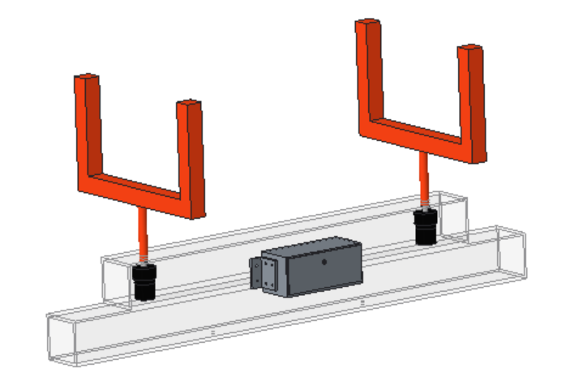
Figure 9: ProE Model of Preliminary Design 3.

3.2.2 Preliminary Design 2
Table 4 shows the outcome of the second iteration of the morphological method.
Table 4: Morphological Chart for Design 2.^{[7]}
Requirements | Functional Parameters | Concepts to Satisfy the Function
Motion | Type of Motor | Servomotor |  | Stepper Motor
 | Power | Single Motor |  | Dual Motor
 | Targets | Dependent |  | Independent
Stability | Support/Sleeve Connection | Integrated | Bracketed |  | Welded
Lightweight | Material | Aluminum 6061 | Steel |  | Carbon Fiber
Durability and Electronics Protection | Bullet Resistance | Metal Housing | Inside Support Beam |  | Underwater Housing
 | Water Resistance |  |  |  | Pelican Case

Like the first preliminary design, two motors will be employed to allow independent motion. But the difference in this deign is that the electronics are to be housed inside the integrated support and sleeve component. This leads to a minimalist design, which would be desirable for manufacturing costs. Figure 9 shows a ProE depiction of this morphological chart. For detailed dimensions on all of the design components, refer to Appendix B.
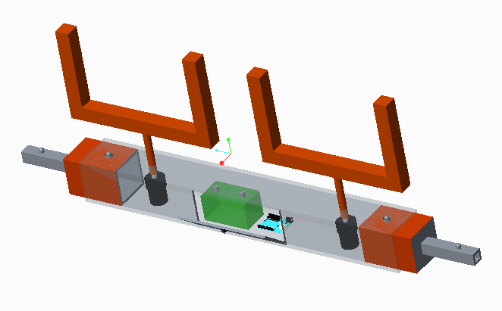
Figure 10: ProE Model of Preliminary Design 2.

3.2.3 Preliminary Design 3
Table 5 shows the outcome of the third iteration of the morphological method.
Table 5: Morphological Chart for Design 3.^{[7]}
Requirements | Functional Parameters | Concepts to Satisfy the Function
Motion | Type of Motor | Servomotor |  | Stepper Motor
 | Power | Single Motor |  | Dual Motor
 | Targets | Dependent |  | Independent
Stability | Support/Sleeve Connection | Integrated | Bracketed |  | Welded
Lightweight | Material | Aluminum 6061 | Steel |  | Carbon Fiber
Durability and Electronics Protection | Bullet Resistance | Metal Housing | Inside Support Beam |  | Underwater Housing
 | Water Resistance |  |  |  | Pelican Case

In this final preliminary design, there are two main differences. One is that there would be a single motor that powers the motion of both targets, which does not allow for independent motion. This would however bring down the cost of manufacturing. The other notable difference is that the electronics housing would be located under water in a metal unit. The location of this unit was decided from the potential upside of the major increase in bullet protection of the electronics. The obvious downside to this feature if that the risk of water damage is also increased. Figure 10 shows a ProE depiction of the third iteration of the morphological method. For detailed dimensions on all of the design components, refer to Appendix B.
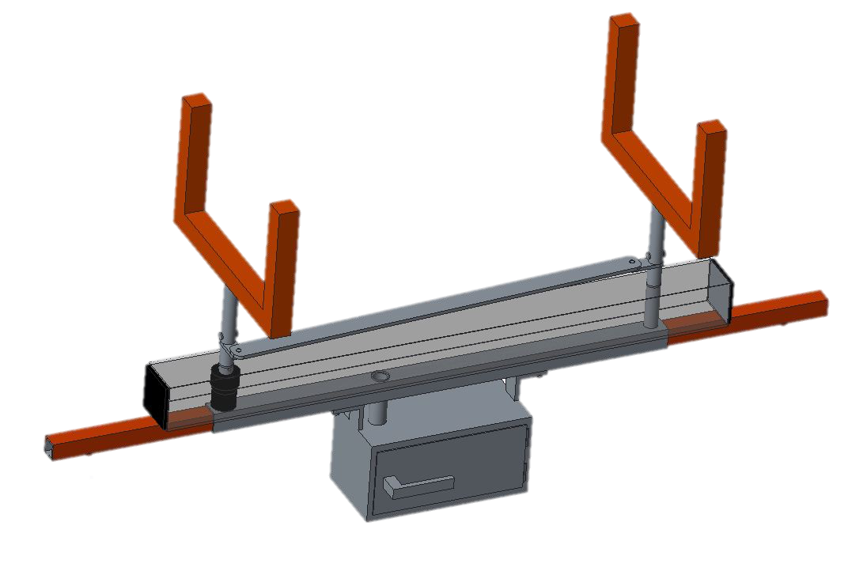
Figure 11: ProE Model of Preliminary Design 3.

- Design and Analysis

  - Selected Preliminary Design
    - Mechanical Design
The project objectives clear specific mechanical problems with the prototype design that need solutions. The first and foremost was the mechanical instability that the turning mechanism had with the rest of the frame. Measurements were taken while the mechanism was connected to the rest of the frame, and it was calculated that the target tilted out of the frame by an angle of 13.1 degrees. This results in the top of the frame to lean out of the frame by approximately 12 inches. Considering that this target system is going to be used in an environment where wind is a major factor, it is an unacceptable design flaw. In order to address this issue, Team 21 will combine the support bar of the turning mechanism with the sleeve that connects the two arms on the bottom part of the frame by welding the two metal pipes together. By welding the two parts together, it will integrate the whole turning mechanism straight to the target system as a single component.

Another objective that the team had to address was improving the functionality of the system. The prototype itself had no specific stopping procedure for the 90-degree rotations. A piece of metal would impede the motion of the motor which would force-stop the targets in the desired position. In order to avoid this, Team 21 will employ a code that will allow for the specific desired motion of the motor to be 90 degrees and then stop without the need of any brute stop which may cause damage to the motor.
Since the group is still in a preliminary testing phase, motor selection has not been done yet. Testing of the code will be done using the motor of the prototype in order to ensure functionality of the electronics. In order to select the proper motor, the load that the motor will be moving will have to be calculated in order to select a motor of the proper torque rating. In order to find the proper torque rating, the mass moment of inertia of a single target has to be calculated and include any external loads such as drag from the motion of the target turning and wind speed.

The last objective to be addressed was the location of the electronic housing. Where it stands on the prototype is too close to the targets. It has a high chance of getting hit with a stray bullet. The sponsor expressed that rather attempting to improve the bullet resistance of the electronic housing he would rather reduce the chance of the electronic housing being hit. With this in mind, the relocation of the electronic housing would be easier to do with a machined metal electronic housing since it would allow more versatility in attachment to any part of the target system. It would be able to maintain the water-resistance the current housing has by having a rubber seal on the inside of the hatch, much like those of water pumps for domestic pools.
In order to make a bullet-proof electronic housing, manufacturing cost would have to increase considerably in order to use a bullet-proof material. He also expressed that the target system will be advertised to be used with Simunition. As Simunition is only a tracer cartridge that allows a user to shoot a non-lethal projectile, it would cause no structural damage to any part of the target system as a whole. The user may use real fire at his or her disgression, however, he or she will be notified that using such ammunition may cause damage to the target system and could result in replacement of parts.

At the conclusion of these mechanical analyses, Team 21 conducted a failure mode analysis of the mechanical system of the turning mechanism in order to know what could go wrong, why it would go wrong, and how to avoid such situations. If any mechanical failure could be preemptively avoided while going through the iterative design process, the final design would result in a more robust design overall. Below is the failure mode effects and analysis conducted for the mechanical design.
Table 6: Mechanical FMEA
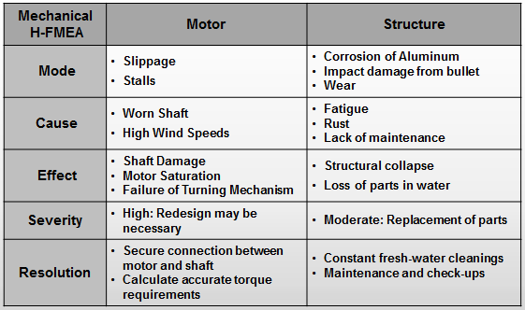

During the presentation, there were a few alternative design possibilities that were brought up in terms of the mechanical instability of the turning mechanism and the relocation of the pelican case. The first alternative option was instead of welding the support bar of the turning mechanism to the sleeve of the target system to solve the instability issue, a rod which would be inserted at the top and middle of the target could be attached to the top of the frame in order to make a connection with between the target and the target system.
The other design alternative was rather of machining a new electronic housing which would have to be designed for water resistance was to keep the current pelican case and create an aluminum housing for that case in order to allow ease of attachment between the housing and the target system.

4.1.2 Electronic Components

The arduino Uno has been chosen for its support, easy implementation and ability to implement the necessary components of the design such as the serial communication ports. Seeed studio Rf transmitter and transmitter has been chosen for this design because of its long range capabilities. Implementation of this device will consist of wiring the transmitting and receiving ports to the corresponding serial Tx/Rx ports on the microcontroller. The Adafruit EZ-link bluetooth module is the only bluetooth researched to have the capability to pair with android and IOS devices. Configuration of the module to the microcontroller will also be through the serial communication port on the Arduino. The battery chosen for the on-board unit is a 12V Li-ion 3000mAh pack. It is allowable for recharge through a separate auxiliary charger. The pack will be able to power the unit approximately 20 hours until charging is needed. Below in Figure 12 is a schematic of the electronic system of the turning target system.

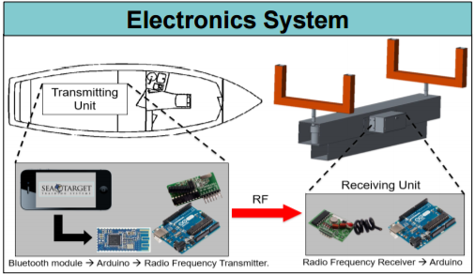
Figure 12: Electronic Systems Schematic

    - Software Development

After taking into consideration the many different types of integrated development environments (IDEs) to use for coding the smart device application, it was best determined to go with Xcode 8 for Apple products app development and Android Studio 2.2.2 for any Android operating devices. Xcode was chosen because of a few main features that would be very beneficial to the software engineers such as Interface Builder, Storyboard, Fix-It, etc. Interface Builder allows for an application interface to be developed and tested without having to write a single line of code. This allows the software engineers to be able to set an outline for what they want the app to look like before actually implementing any code. The code then can be linked to the interfaced that was created. Storyboard builds off of the Interface Builder as it allows you to take your interface design and link them together with actual button actions. For example, if I had a home screen for an app and it had five different options to choose from, storyboard will help you to see once those options are chosen what will happen next, such as clicking on the settings button and it take you to the settings page. Fix-It is a feature that automatically alerts to when an error in coding has been made. This is very beneficial because when an error is made, it catches it immediately as opposed to when all the code is finished being written and errors occur. At that point, you have to go back through all the code and try to determine what the issue is. Fix-It makes it so you can fix your issues in a matter of seconds as opposed to hours.
Android Studios has just about all the same features as Xcode such as Blueprint (which is like Interface Builder), Intelligent Code Editor (which is like Fix-It), Translation Editor (which is like Storyboard) but it does have a few differences. Android Studios has a feature called Instant Run. When you change something in your original code, you can just click run/debug and it will run your application without you having to save your new code. This feature is amazing because you can see what changes your code made to the application and if you like what the changes did, then you can keep them and save the code and if not, then you can scrap them and keep the original code that you had before. It also has an APK Analyzer which lets you see how big your app is going to be for download and shows all the download files associated with the application. This feature is great for checking to see how big your application will be and if you need to reduce some of the code that is in the file. You do not want an app with a ridiculous download size because people limited on space would not want to download the app.
For the reasons mentioned above, we have decided to go with these two IDEs. The app code will first be written in Android Studio and tested on Android devices. After testing comes back positive for the app on the Android side, the code will then be transferred to Xcode and if any necessary changes are to be made, they will be made over on that side. The app will then again be tested on the Apple devices. Once that is done, the app will have to be linked to the Bluetooth module to provide functionality to the electronic, mechanical components.

- Future Work

  - Rough Manufacturing
Once all the electronic parts and materials have been received it is now time to put together the initial prototype design. This will enable the team to detect the early issues the product may have down the road. Alpha testing will be strictly a functional test. Calculations and dimensions will be very rough at this stage. These tests will just allow for the observation of the product to take place, the team will just see if the product can even function at its most basic level.
The existing prototype that Jason Knowles; the sponsor, provided the team cannot be used for experiments and testing. Therefore, he has provided plenty of scrap metal and spare parts to begin initial prototype design construction. Based off of design one that was selected, a very rough design will be manufactured in order to keep testing costs low and conserve time. The goal is to build a functional prototype quickly and inexpensively in order to work out all the bugs very early on so that the team may spend more time on refinement and final design.
This rough prototype will execute and obtain all the functions and features, respectively, that design one has to offer but on a smaller scale. For instance, initial testing will only involve a single target and motor. The idea is that if the design team can get a single target to execute the desired function wirelessly then enlarging the scope to two targets should not be much of a challenge. The challenge is to get a single command met through the app controlled system.

  - Electronics and Software Testing
As of right now, all of the electronics have been received and are ready for initial testing. By the beginning of January and the start of the new school semester, we are expected to be done with all of the code development for the electronics. This includes the Bluetooth communication between the phone and the Bluetooth module as well as the radio frequency communication between the boat unit and the target unit.
For the microcontroller code, we are planning to use Code warrior which the college of engineering provides on the computers in the mechatronics laboratory. Once the code is written testing and troubleshooting will begin. We will connect all of the components and try to move the motors. Initially we may have to use a serial port to manually control the motors with the keyboard. We will have to do this if the application is not complete and we can’t use a smartphone yet. If this is necessary, we will also employ the use of code blocks to connect to the keyboard.

  - Design Refinement
Refinement in design and engineering will occur right after a successful prototype test has been observed. Now that the prototype has been proven to work it is necessary to get a little more detailed with the design calculations and dimensions. The material can now begin final manufacturing; the motors can be properly sized with accurate performance specification including the electronics with proper voltage output.
It is important to note that now is time to take a little more time and attention to all the little details. Besides the design calculations, dimensions and tolerances must be taking into full consideration, furthering the design into finalization. In addition, accurate placement of all the components must be thought out carefully as initial prototype testing assisted in this particular area as well. Final manufacturing can take place, the time and funds may begin to be directed towards this step. The beta testing will take place afterwards, where final details and bugs, if any may be caught and corrected.

  - Final Design Testing
Just before unveiling the final product the design must go through beta testing. The detailed design, final dimensions and tolerances will be put to the test at this stage. This includes the electronics and software components of the design. The wiring and electronics will get a last check to see everything is connected properly; consider safety hazards and worst case scenarios. Their functions have already been tested this will just insure precision and dependability. The final code and app functions will be further examined. The team will work extensively searching for flaws and deficiencies the app may have.
The customer or sponsor will also aid in this step. This test will be introduced to the customer in order to insure every goal has been met. During beta testing, the customer will get a first look at what the final product may look like. They will give us input on finalized design; suggestions or complaints. Time for this process has been reserved due to the fact discrepancies were expected to arise. There might be certain features and details that the customer might not be satisfied with and this gives the team sufficient time to correct them. Very basic requirements will be met at this time; therefore only minor corrections will be made at this point as this will be very close to the end of final product demonstration.

- Results
After having created all three different preliminary designs, Group 21 had to go through the process of deciding which of the three designs was the most optimal for the project scope. In order to do this, they used the decision matrix shown in Table 6 below.

Table 6: Decision matrix. +1 (better), 0 (same), -1 (worse). Secondary check through CI’s.^{[7]}
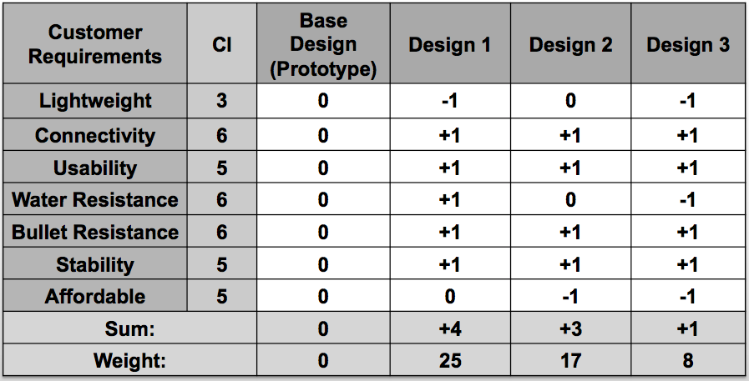

What the decision matrix did was compare the prototype with the different designs and show whether the preliminary designs were better or worse according to the customer requirements set by the sponsor. If a design was better than the prototype in a requirement, it would be assigned a “+1” and if it was worse in a requirement in comparison to the prototype, it would be assigned a “-1”. After assigning values to each of the designs according to all the customer requirements, the scores were added up. As seen below, the first preliminary design scored the highest among the three designs.
Design 1 had the highest score because it was the best overall in comparison to the prototype. The only category it lacked in was being lightweight, which was caused by the fact that the pelican case would be replaced with a metal housing for the electronics and two motors would be used as opposed to one. Design 2 was also an overall improvement from the prototype, however, it fell short of design one because it was equivalent in weight and water resistance as the prototype. It also lacked in being affordable since the support bar would require to be a stronger material, as it would act as not only a support bar for the targets, but also as a housing for the electronics. Design 3 was the worst of the three preliminary designs because it was worse than the prototype in the same customer requirements as design two. It would be a heavier mechanism due to the replacement of the pelican case with the metal housing, and it would lack in water resistance since the metal housing itself would be underwater. As mentioned before, should any damage occur to the metal housing while it is under water, any kind of deformation could allow water to breach in and damage the electronics. It would also be less affordable than the prototype because of the metal electronic box as well as machining the mechanical system that would allow one motor to move both targets.
The resulting design that was selected has enabled the team to have a working concept to test. The team can now work off of this idea to further refine and bring product to realization. The first step is to test the idea; a functional test with very rough design and sizing in order to prove the concept. Once this has been accomplished the detailed design and dimensioning may take place.
- Conclusion
The sponsor for this project, Jason Knowles, is the CEO of Hard Target Security Group. As a former USMC SCOTUS sniper and marksmanship training coordinator, he established his own set of requirements he would want in his own training sessions. The group brainstormed to create a clear set of engineering characteristics governing the design process and correlated each engineering characteristic to each customer requirement. This process is exemplified in the House of Quality shown above. The process of the creating the House of Quality also included competitor comparisons. After researching similar designs of the sponsor’s prototype the group concluded that there is an abundance of land based turning target system but none with maritime capability. The maritime target system will be improved by the addition of a modern turning target system. The turning system has Wi-Fi connectivity through an application that can be downloaded from an iOS or Android devices. The modified turning mechanism will be attached to the target frame which the sponsor, Jason Knowles, designed and has created a physical prototype.
The HOQ assisted us in identifying the most important engineering characteristics that will govern our initial designs. A few initial concepts came to fruition with the combination of brainstorming and a morphological chart. These designs were hand sketched and later CAD drawn in order to get a visual representation of these configurations produced by the morphological chart. The team created a design matrix comparing all generated concepts to the existing working prototype. It was concluded that Design 1 was the most adequate design in regards to customer requirements and their importance.
A final prototype has been selected for initial design and testing. Design 1 will be presented to the customer for initial approval. In addition, a risk assessment will be laid out for the prototype so that the team can assure some early success during preliminary testing and analysis. The team’s goal for the remainder of the semester is to identify the shortcomings of the project. Product architecture, performance specification and initial testing will be executed during the next month in order to produce some meaningful results. Recognizing the flaws of the initial design early on in the process leaves a lot of time for potential redesigning and/or multiple iterations on initial concept.

References
[1] SPTargets, Company, Webpage: http://sptargets.com/turning-target-system-footage/.
[2] Elite Target Systems, Company, Webpage: www.elitetargetsystems.com/youtubevideo.html
[3] MotoShot, A Hale Outdoor Product, Webpage: http://www.motoshot.com/target-turner
[4] Arduino Uno webpage: https://www.arduino.cc/en/Main/ArduinoBoardUno
[5] ESP8266 Wi-Fi module Webpage: https://www.sparkfun.com/products/13678
[6] Robotshop Speedstudio webpage: http://www.robotshop.com/en/seeedstudio-433mhz-rf-long-distance-transmitter-receiver.html
[7] Dieter, George E., Schmidt, Linda C., (2013). Engineering Design, Fifth Edition. 1221
Avenue of the Americas, New York, NY, 10020: McGraw-Hill

Appendix A
Appendix A is comprised of detailed ProE drawings of design 1.
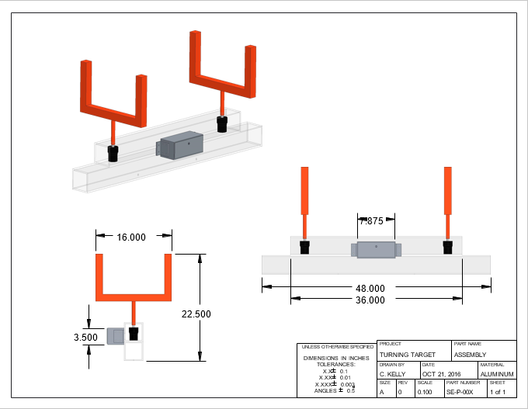
Figure 15: Dimensioned Drawing of Design 1 Assembly.
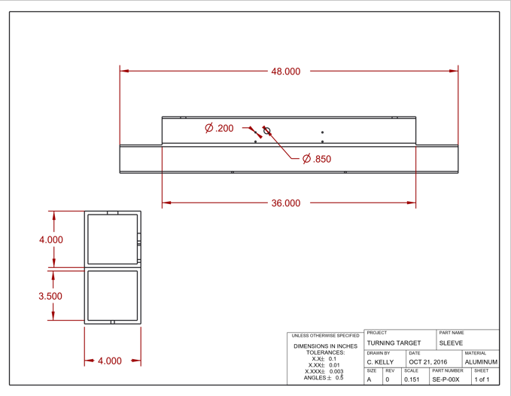
Figure 16: Detailed Drawing of Design 1 Component.
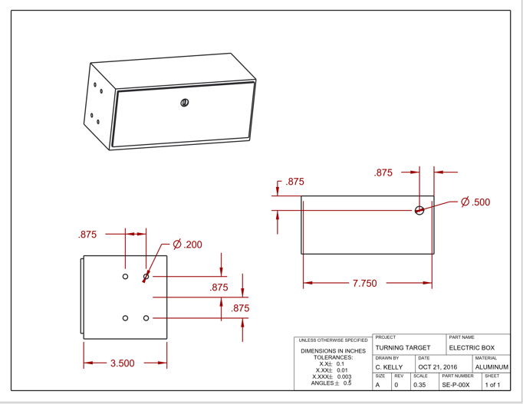
Figure 17: Detailed Drawing of Design1 Component.
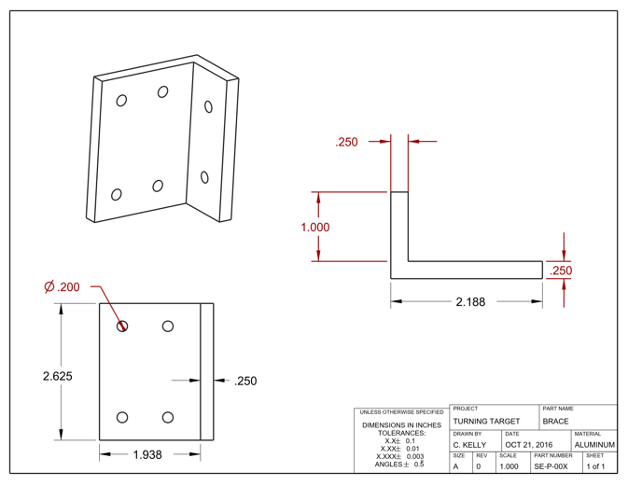
Figure 18: Detailed Drawing of Design 1 Component.

Appendix B
Appendix B is comprised of detailed ProE drawings of design 2.
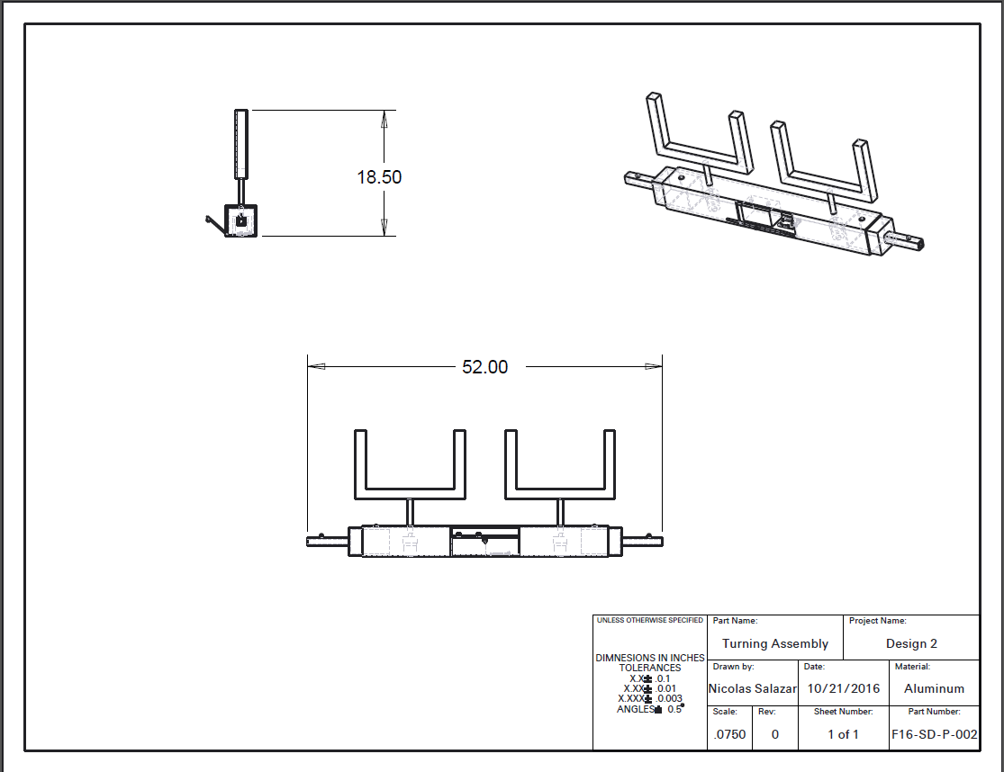
Figure 19: Dimensioned Drawing of Design 2 Assembly
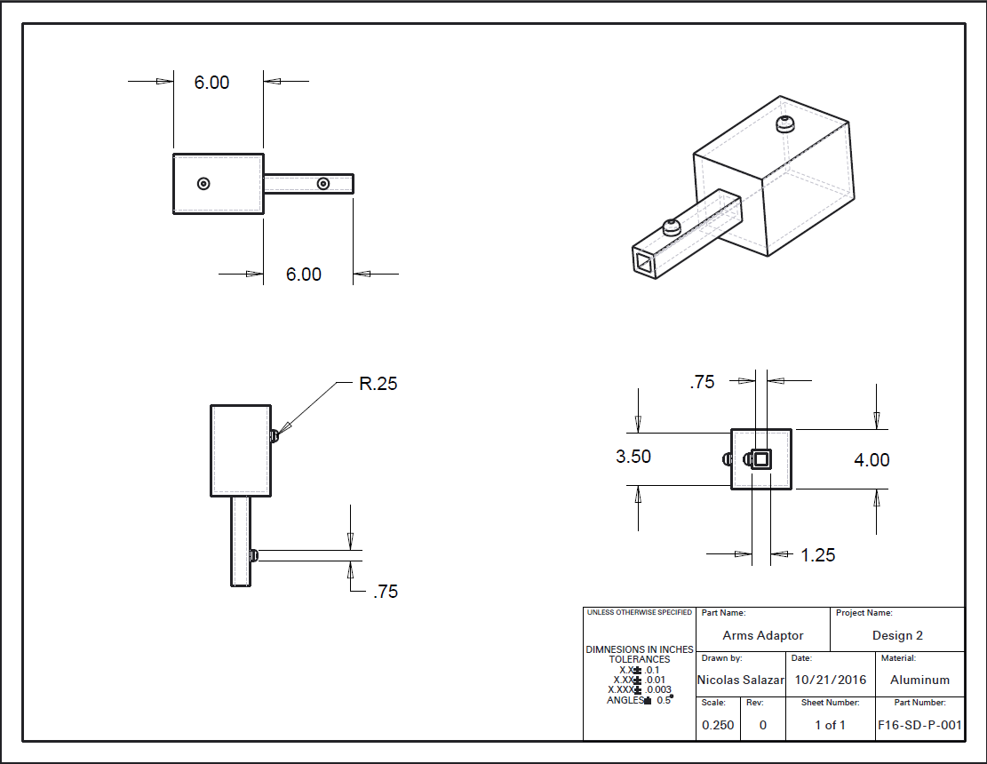
Figure 20: Drawing of Arm for Design 2.

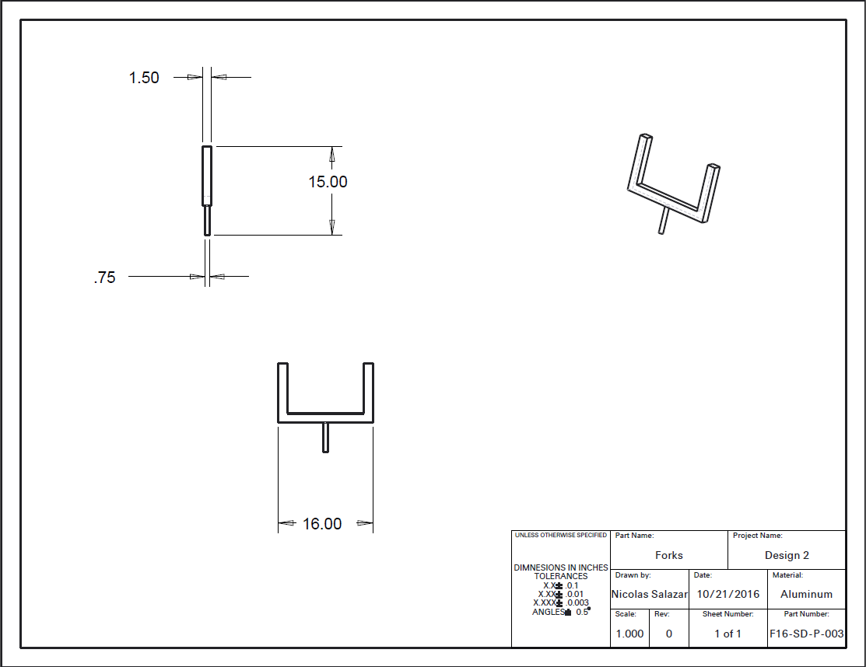
Figure 21: Drawing of design 2 target mounts.

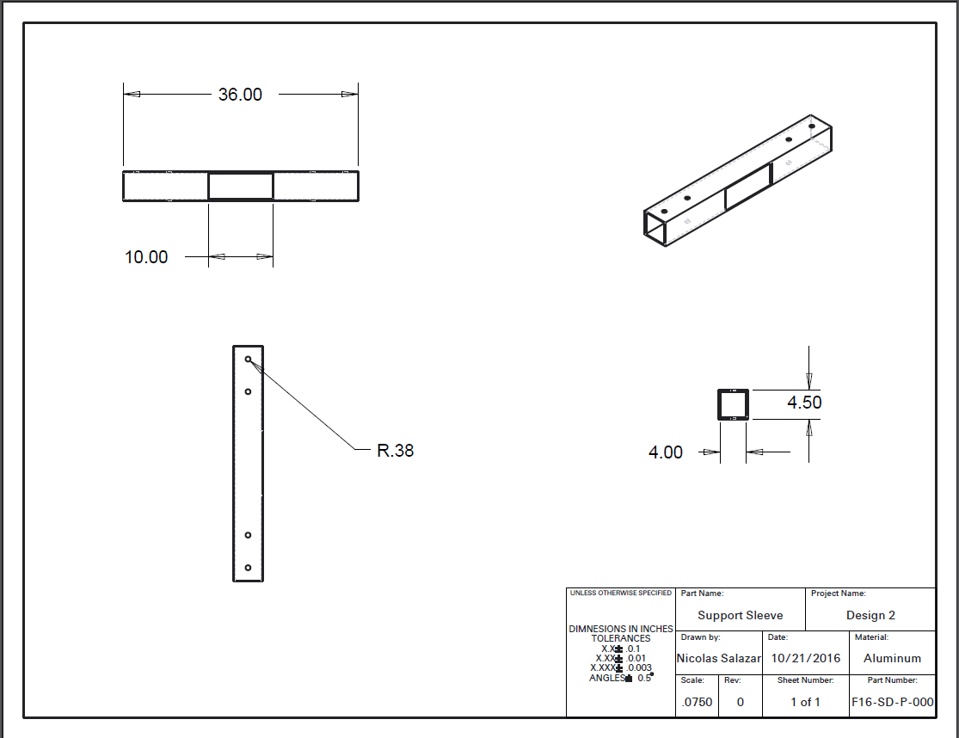
Figure 22: Integrated Sleeve and Support.

Appendix C
Appendix C is comprised of detailed ProE drawings of design 3.
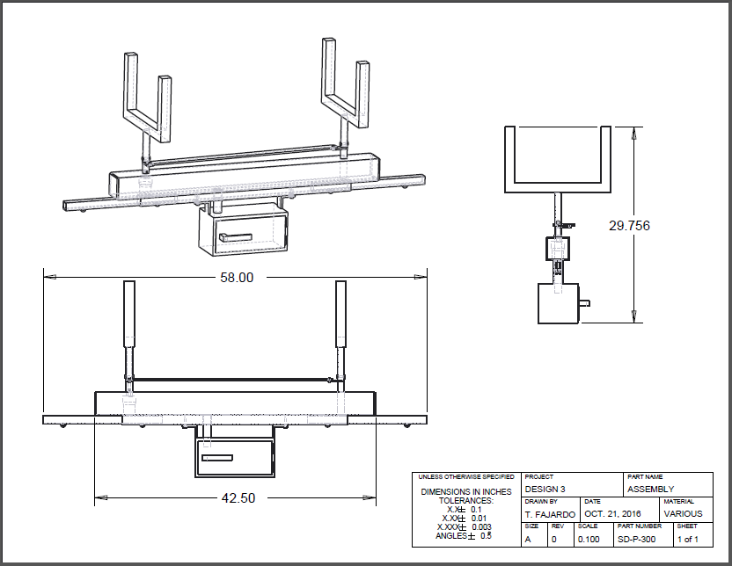
Figure 23: Detailed Drawing of Design 3 Assembly.
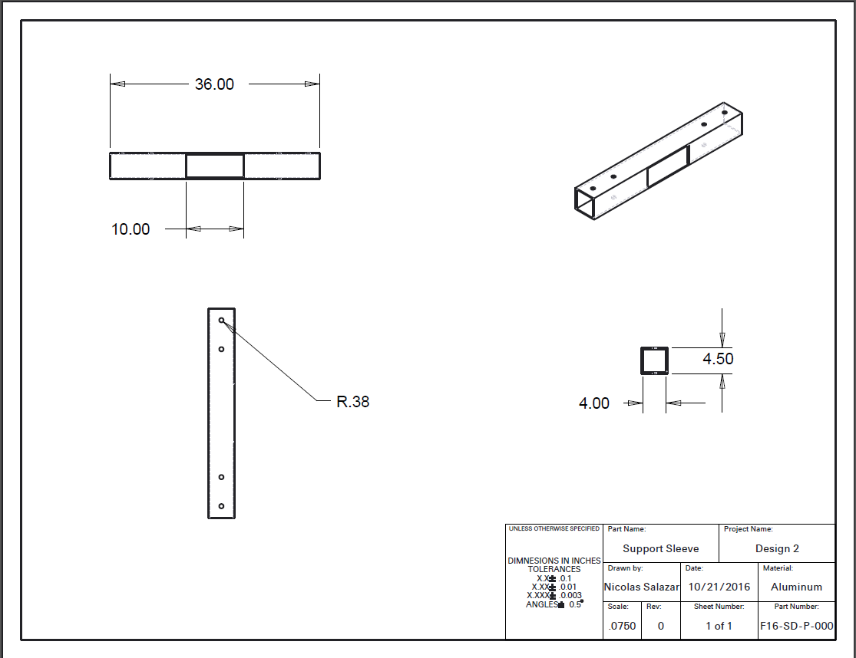
Figure 24: Drawing of Design 3 Component.

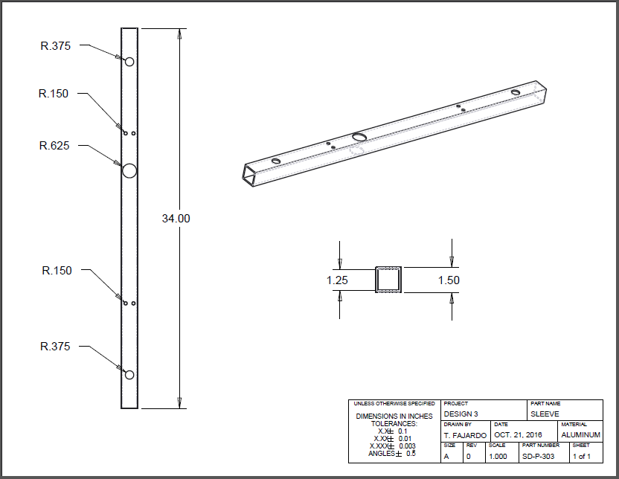
Figure 25: Detailed Drawing of Design 3 Component.
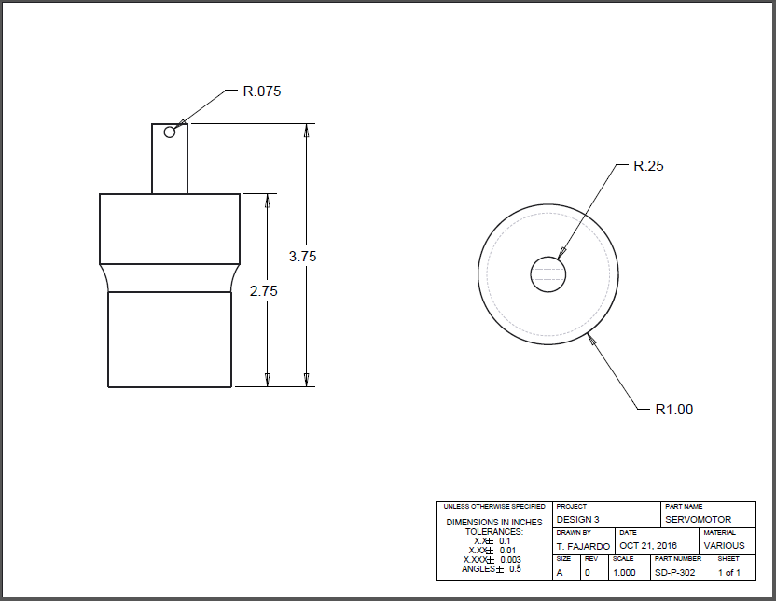
Figure 26: Detailed Drawing of Design 3 Component.

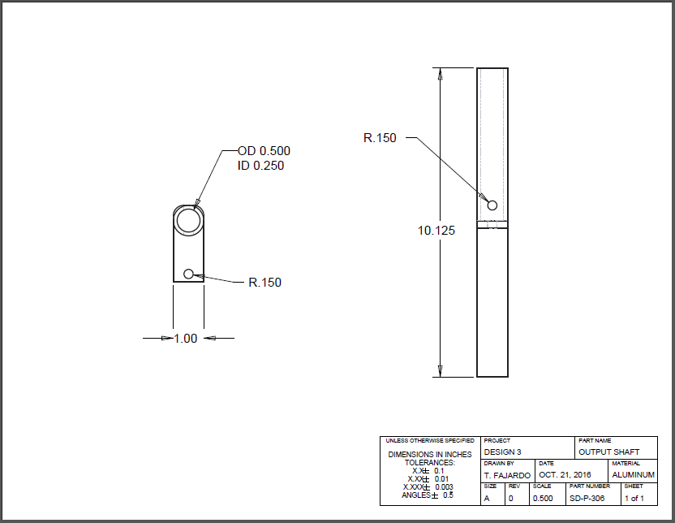
Figure 27: Detailed Drawing of Design 3 Component.

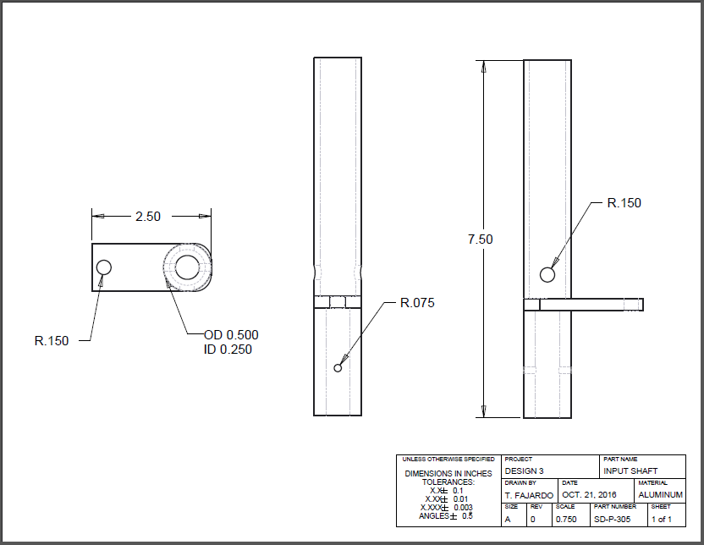
Figure 28: Detailed Drawing of Design 3 Component.
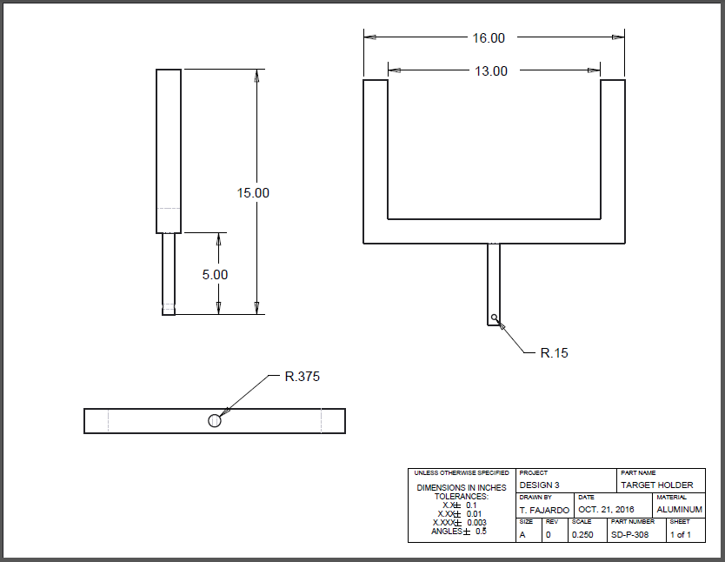
Figure 29: Detailed Drawing of Design 3 Component.

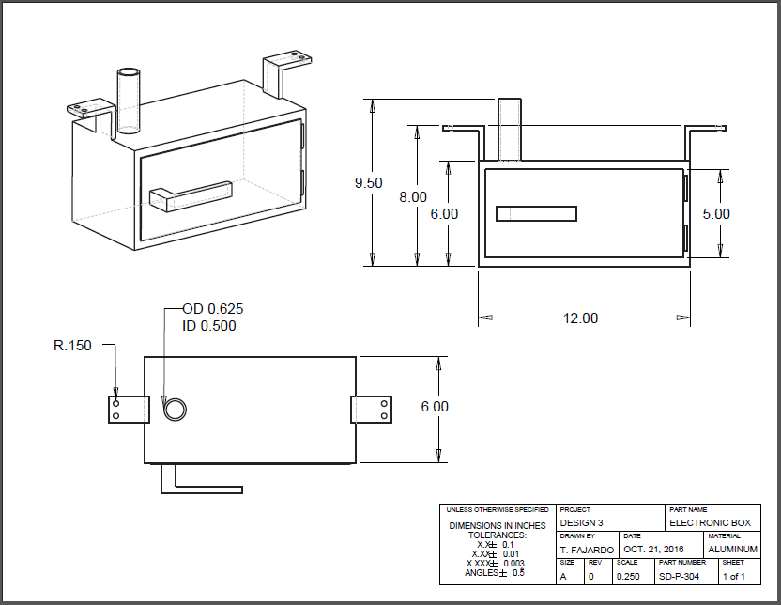
Figure 30: Detailed Drawing of Design 3 Component.
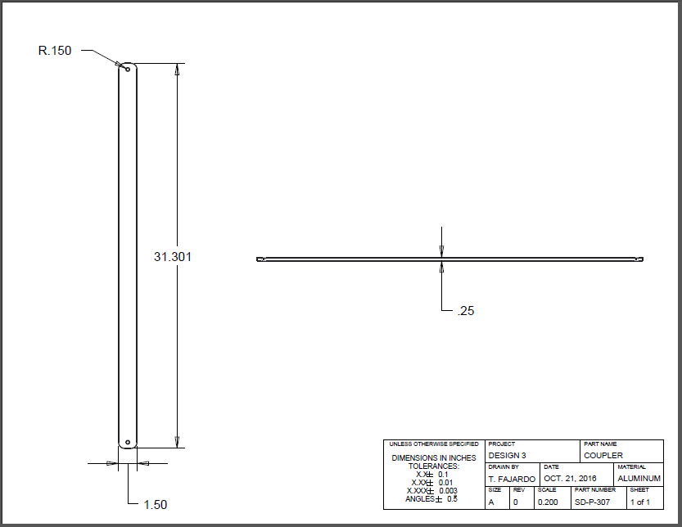
Figure 31: Detailed Drawing of Design 3 Component.

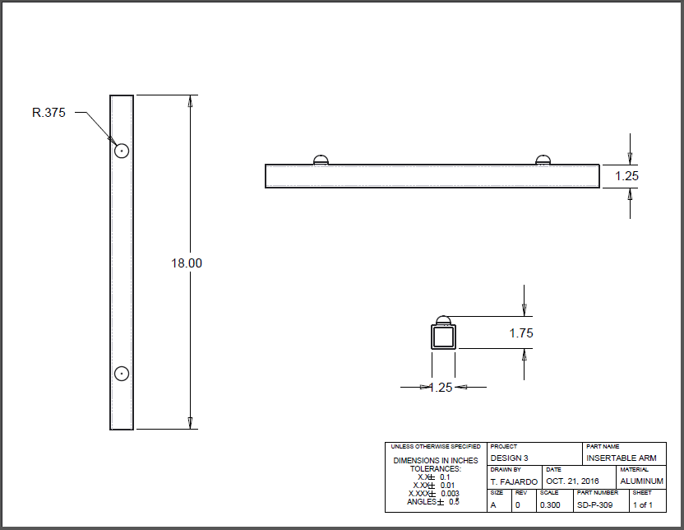
Figure 32: Detailed Drawing of Design 3 Component.

Biography
Charles Kelly is a senior mechanical engineering student at the FAMU-FSU College of Engineering and is pursuing specialization in the thermal-fluids track. Charles is the Lead Financial Advisor for Group 21’s project.

Jonathan Rhoads is a senior in electrical engineering. Generally specialized in computer hardware, electromagnetics, power systems, and communications. In my free time I enjoy long walks on beaches, starting random projects at my house, and traveling.

Nicolas Salazar is a senior mechanical engineering student at the FAMU-FSU College of Engineering. He is the Lead Materials Engineer for Group 21. His experience ranges from the automobile restoration industry to engineering research at HPMI in material science and renewable energy and sustainability systems research at CAPS.

Scottie Milton is a senior computer-engineering student at FAMU-FSU College of Engineering. He has experience in networking and software engineering thanks to an internship at Florida State College at Jacksonville in Jacksonville, FL. Scottie Group 21’s Lead Media Specialist.

Timothy Lootens is a senior mechanical engineering student at FAMU-FSU College of Engineering. He has expertise in robotics and mechatronics from having volunteered at CISCOR lab in the AME building and is currently a teaching assistant for mechatronics under Dr. Camilo Ordoñez. Timothy is the team leader for Group 21.
Tomas Fajardo is a mechanical engineering student pursuing a dynamic systems track with a focus in control systems. He works as a teaching assistant for Dr. Dorr Campbell in Mechanics of Materials I and also works under Dr. Chengying Xu in the Smart Ceramic Manufacturing Lab. Tomas is the leading ME for Group 21.

